**Project book to add books and display book list**

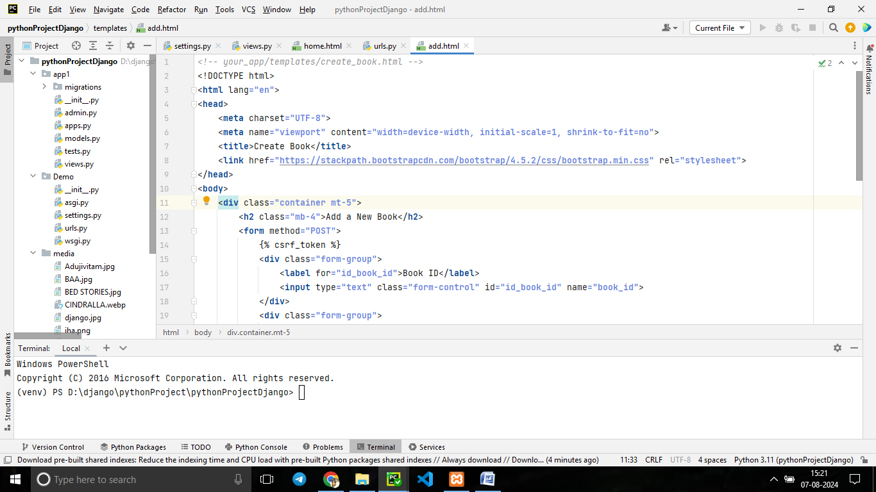

**Create a database in xampp name 'bookdata'**

**Models.py**

**from** django.db **import** models  
  
*# Create your models here.***class** Book(models.Model):  
 book_id = models.IntegerField(primary_key=**True**)  
 book_name = models.CharField(max_length=**230**)  
 book_price = models.IntegerField()  
  
 book_image = models.ImageField(upload_to=**''**)  
  
 **class** Meta:  
 db_table = **'book_table'**

**views.py**

**from** django.shortcuts **import** render,redirect  
**from** app1.models **import** Book  
*# Create your views here.***def** add_book(request):  
 **if** request.method == **'POST'**:  
 book = Book() #Book is the model  
 print(book)  
 book.book_id = request.POST.get(**'book_id'**)  
 book.book_name = request.POST.get(**'book_name'**)  
 book.book_price = request.POST.get(**'book_price'**)  
 book.book_image = request.POST.get(**'book_image'**)  
 book.save()  
 **return** redirect(**'/home'**)  
 **return** render(request,**'add.html'**)  
  
**def** home(request):  
 book = Book.objects.all()  
 **return** render(request,**'home.html'**, {**'data'**:book})

add.html

*<!-- your_app/templates/create_book.html -->*<!DOCTYPE html>  
<**html** lang**="en"**>  
<**head**>  
 <**meta** charset**="UTF-8"**>  
 <**meta** name**="viewport"** content**="width=device-width, initial-scale=1, shrink-to-fit=no"**>  
 <**title**>Create Book</**title**>  
 <**link** href**="https://stackpath.bootstrapcdn.com/bootstrap/4.5.2/css/bootstrap.min.css"** rel**="stylesheet"**>  
</**head**>  
<**body**>  
 <**div** class**="container mt-5"**>  
 <**h2** class**="mb-4"**>Add a New Book</**h2**>  
 <**form** method**="POST"**>  
 {% csrf_token %}  
 <**div** class**="form-group"**>  
 <**label** for**="id_book_id"**>Book ID</**label**>  
 <**input** type**="text"** class**="form-control"** id**="id_book_id"** name**="book_id"**>  
 </**div**>  
 <**div** class**="form-group"**>  
 <**label** for**="id_book_name"**>Book Name</**label**>  
 <**input** type**="text"** class**="form-control"** id**="id_book_name"** name**="book_name"**>  
 </**div**>  
 <**div** class**="form-group"**>  
 <**label** for**="id_book_price"**>Book Price</**label**>  
 <**input** type**="number"** class**="form-control"** id**="id_book_price"** name**="book_price"**>  
 </**div**>  
 <**div** class**="form-group"**>  
 <**label** for**="id_book_image"**>Book Image</**label**>  
 <**input** type**="file"** class**="form-control-file"** id**="id_book_image"** name**="book_image"**>  
 </**div**>  
 <**button** type**="submit"** class**="btn btn-primary"**>Submit</**button**>  
 </**form**>  
 </**div**>  
 <**script** src**="https://code.jquery.com/jquery-3.5.1.slim.min.js"**></**script**>  
 <**script** src**="https://cdn.jsdelivr.net/npm/@popperjs/core@2.5.4/dist/umd/popper.min.js"**></**script**>  
 <**script** src**="https://stackpath.bootstrapcdn.com/bootstrap/4.5.2/js/bootstrap.min.js"**></**script**>  
</**body**>  
</**html**>

Home.html

*<!-- your_app/templates/book_list.html -->*<!DOCTYPE html>  
<**html** lang**="en"**>  
<**head**>  
 <**meta** charset**="UTF-8"**>  
 <**meta** name**="viewport"** content**="width=device-width, initial-scale=1, shrink-to-fit=no"**>  
 <**title**>Book List</**title**>  
 <**link** href**="https://stackpath.bootstrapcdn.com/bootstrap/4.5.2/css/bootstrap.min.css"** rel**="stylesheet"**>  
</**head**>  
<**body**>  
  
 <**div** class**="container mt-5"**>  
 <**a** href**="{% url 'add_book' %}"** class**="btn btn-primary mb-4"**>Add New Book</**a**>  
 <**h2** class**="mb-4"**>Book List</**h2**>  
 <**table** class**="table table-striped"**>  
 <**thead**>  
 <**tr**>  
 <**th** scope**="col"**>ID</**th**>  
 <**th** scope**="col"**>Name</**th**>  
 <**th** scope**="col"**>Price</**th**>  
 <**th** scope**="col"**>Image</**th**>  
 </**tr**>  
 </**thead**>  
 <**tbody**>  
 {% for x in data %}  
 <**tr**>  
 <**th** scope**="row"**>{{ x.book_id }}</**th**>  
 <**td**>{{ x.book_name }}</**td**>  
 <**td**>{{ x.book_price }}</**td**>  
 <**td**>{% if x.book_image %}  
 <**img** src**="{{ x.book_image.url }}"** alt**="{{ x.book_name }}"** style**="max-width: 100px;"**>  
 {% else %}  
 No image available  
 {% endif %}</**td**>  
 </**tr**>  
 {% endfor %}  
 </**tbody**>  
 </**table**>  
 </**div**>  
  
 <**script** src**="https://code.jquery.com/jquery-3.5.1.slim.min.js"**></**script**>  
 <**script** src**="https://cdn.jsdelivr.net/npm/@popperjs/core@2.5.4/dist/umd/popper.min.js"**></**script**>  
 <**script** src**="https://stackpath.bootstrapcdn.com/bootstrap/4.5.2/js/bootstrap.min.js"**></**script**>  
</**body**>  
</**html**>

Settings.py

**'app1'** *# +++*

**'DIRS'**: [**'templates'**], *#++++*

DATABASES = { *#+++***'default'**: {  
**'ENGINE'**: **'django.db.backends.mysql'**,  
**'NAME'**: **'bookdata'**, *# +++ db name in xampp***'USER'**: **'root'**,  
**'PASSWORD'**: **''**,  
**'HOST'**: **''**,  
**'PORT'**: **''**,  
**'OPTIONS'**: {  
**'init_command'**: **"SET sql_mode='STRICT_TRANS_TABLES'"**}  
}

}

Create a directory ‘media’

Inside project folder

STATIC_URL = **'static/'**MEDIA_URL = **'/media/'** *#++++*MEDIA_ROOT = os.path.join(BASE_DIR, **'media'**)

Urls.py

**from** django.contrib **import** admin  
**from** django.urls **import** path  
**from** app1 **import** views  
**from** django.conf **import** settings  
**from** django.conf.urls.static **import** static  
  
urlpatterns = [  
 *# path('admin/', admin.site.urls),* path(**'home'**,views.home),  
 path(**''**, views.add_book),  
 path(**'add/'**, views.add_book, name=**'add_book'**), ### button addbook  
]+static(settings.MEDIA_URL, document_root=settings.MEDIA_ROOT)

